**1. Your report should be written in English. The report should include the code (with comments or notes), the resulted figure (or print-screen), and a short discussion on the result if necessary.**

**2. Upload: .m file, .fig file and .doc report**

**3. Pack all the above files and send to 1315480535@qq.com**

**4. The format of pack name: LabX_ID_Name.zip, X is the experiment number.**

**5. Deadline: Saturday in this week.**

**Complete the following tasks:**

1. Consider the Antipodal ‘Return to Zero’ (RZ) baseband signal given on Page 17 of the lecture slides. For the data bit sequence ‘0011001’, plot the corresponding baseband signal wave, where Tb=0.5s, sampling rate fs=1000Hz. the positive and negative levels are 1 and -1, respectively.（绘制基带信号波形，采样率1000Hz，正负幅值1双极性归零信号，Tb=0.5s）

2. For the Antipodal RZ baseband signal, if noise power spectral density (PSD) N0/2=0.1, give the SNR (i.e., E/N0) in dB, and the symbol error rate through Monto Carlo simulation. (Hint: refer to the problem 5-5)（如果加噪声，请给出信噪比和误码率）

3. For the Antipodal RZ baseband signal, plot its constellation diagram. When the signals are suffering noise with PSD of 0.1, plots the resulted constellation diagram. (Hint: refer to Figure (a) on Page 30 of the slides.)（绘制星座图（无噪声和有噪声）双极性归零信号星座图，P30）

4. (Optional) The following is the optimum receiver for Antipodal baseband signal. Try to realize it in Matlab, and verify your code using the noiseless baseband signal wave in Task 1.（实现最佳接收机，并使用task1中的代码验证）

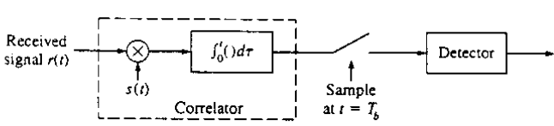

Hint: For the input of the detector, calculate the following Integration for each received signal of length Tb: (recalling how to do Integration in Matlab as mentioned in Lecture 2)



where  is the input of the detector for the *k*th data bit.  is the received signal,  is the baseband waveform.

5.(Optional) Test your code when the received signal has noise with PSD of 0.1. Hint: for each sampling point of the baseband signal, add a Gaussian noise with variance N0fs/2, as mentioned by Step 3 in Example 3.5 of Lecture 3.（带有噪声时，测试代码）